**Cullercoats**

**Helen Nicholson. /Udacity Capstone Project/ VR NanoDegree / HNCullercoats**

Please note that I view this project as a prototype due to limited time scales for development and am looking forward to doing a more polished Version 2. However I do think this prototype meets the criteria for the Capstone Project as it is.

I completed the project in a two week time frame due to timing of Udacity deadlines just after Xmas vacations. As I am not sure whether Jan 12, 2019 is in fact a real deadline or a hard deadline as the Unity website says different - so am checking this out with Udacity support.

Had to make many compromises and reduce interactivity of the app as a result.

Meanwhile continue t l work on a Version 2 of the product that I will be truly happy about as I believe standards and quality are important.

**Description (protoype)**

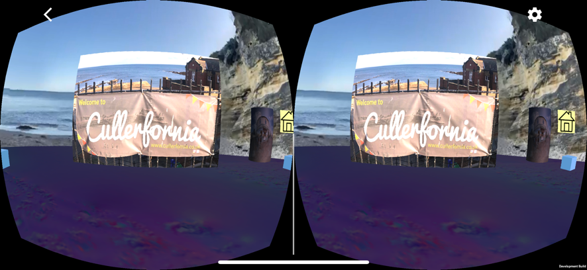

This is an engaging, interactive fun-evoking experience of Cullercoats, a tiny coastal village on the beautiful Northumbrian coast in England, United Kingdom. It is a combination of a “blast from the past” for an older audience with an interactive tourist or historical experience for a wider audience.

Narrated by self & local elderly Geordie to add historical details.

The narration includes memories of a local “Geordie” 94 year old and incorporate local Geordie folk songs and form a key multi-sensory aspect of the app.

This app was developed as is a bi-product of an earlier app “Story Tellers Revenge’.

It aims to provide fun for everyone and for some, love and fondness inevitably mixed with some sadness.

***************************************************************************************

***Using Unity 2017-4-25f2 - Unity Long Term Support (LTS) version***

https://unity3d.com/unity/qa/lts-releases

***Developed on iMac Pro (2017) using macOS High Sierra v10.13.6,***

Processor 3.2 GHz Intel Xeon W, Graphics Radeon Pro Vega 56 8176 MB

Deployed onto iPhoneX iOS 12.1

**Credits**

Peacefield for IceCreamStacked – a super product!

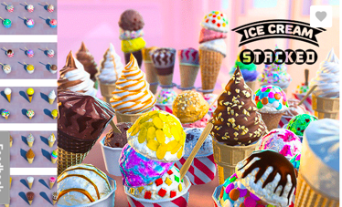

QClone app for photogrammetry (didn’t work very well though – want to get it working for Version 2)

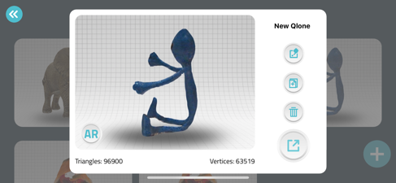

TurboSquid for FishmChipsShop 3D Max model TurboSquid (still waiting for support to convert into fbx format as conversion from 3D Max file only supported in Windows – again want to get it working for version 2 as a basis for interactive 3D menu ordering)

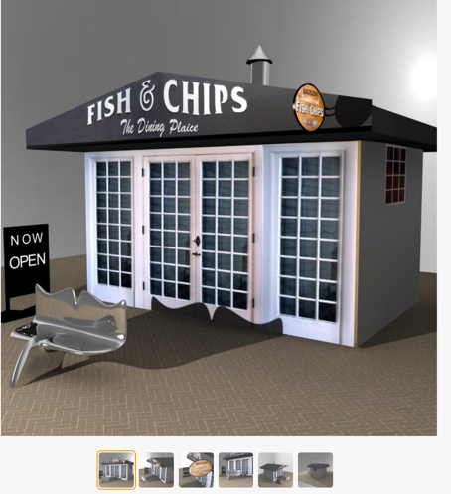

************************************************************************************

**ACHIEVEMENTS**  (total 2,600 pts)

**FUNDAMENTAL** *(total 600 pts)*

1. Scale - 100 pts

*In Ice-cream scene the ice creams cones and tubs are giant size to the user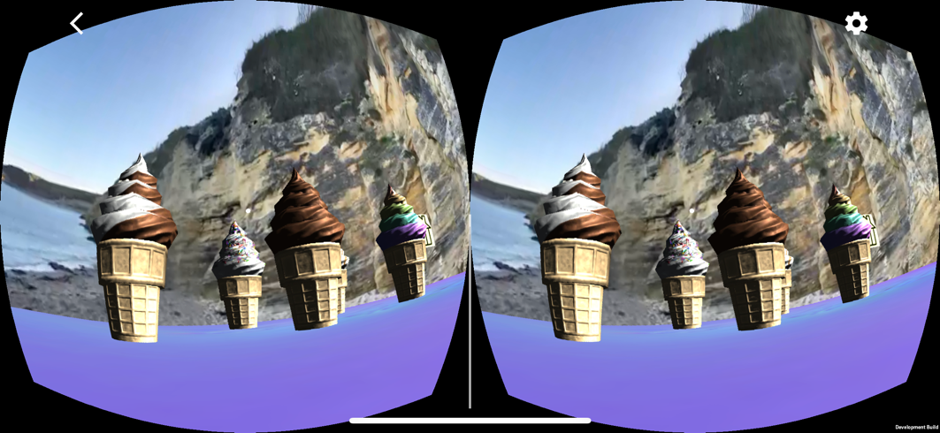*

2. …

3. Lighting - 100 pts

*In all scenes static game objects are baked (soft shadows created)*

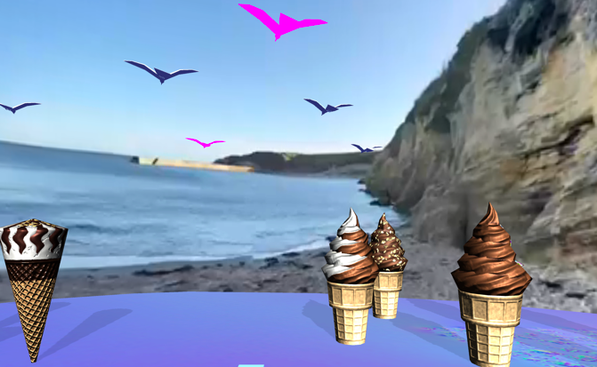

4. Locomotion - 100 pts

*In Beaches ‘n Cream and Bills fish & chips shop scenes, way points are used so that user can travel amongst giant ice-creams*

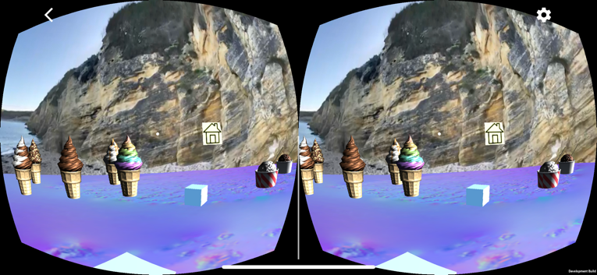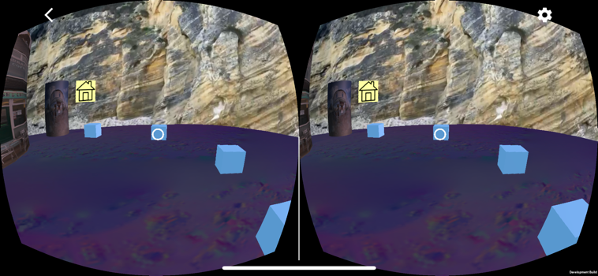

5. …

6. VideoPlayer – 2 x 100 pts (as Lighting achieved)

*360 videos played.*

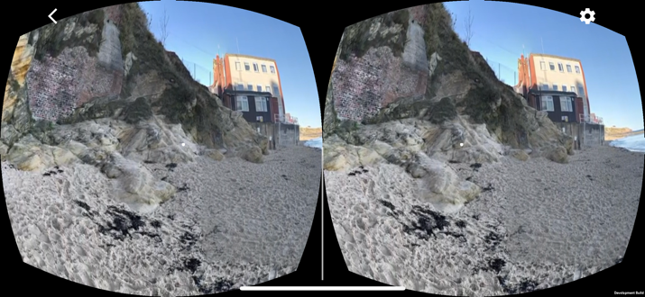

7. Empathy – 100 pts

*App evokes the emotions of joy, happiness and sadness. Deals with bereavement.*

Joy & Wonder of beautiful 360 scenes mixed with local Geordie songs known by all the locals.

Songs include “The Keel Row”, “Thou shalt have a fishy, on a little dishy … when the boat comes in” & “I do like to be beside the seaside”.

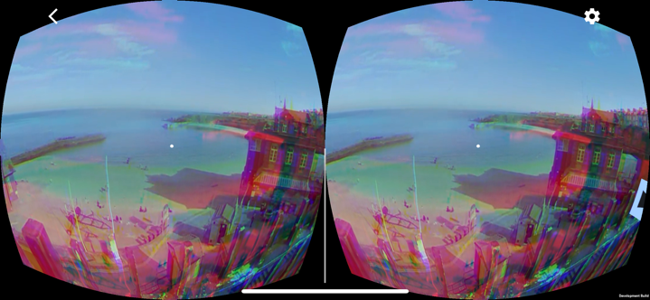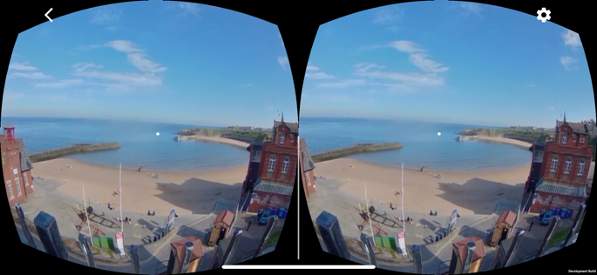

Fun & Happiness …

“You can always start with fish ‘n chips and get ice-cream afterwards. I’ve been coming here for 94 years and still love it”

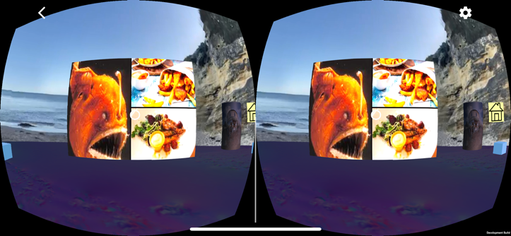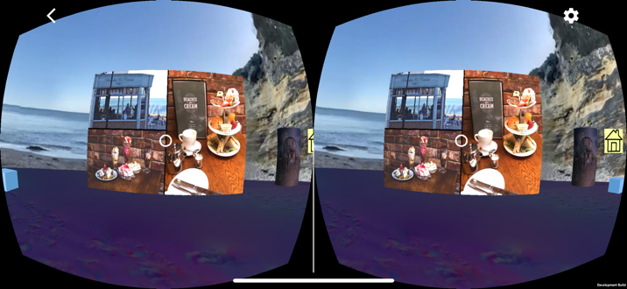

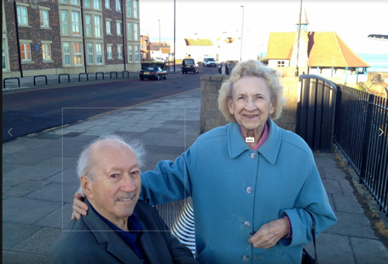

Combination of happiness, good memories touched with sadness – something many older viewers would relate to…

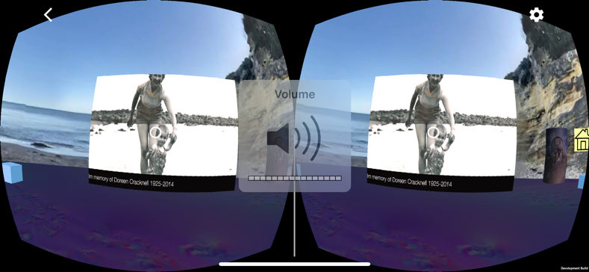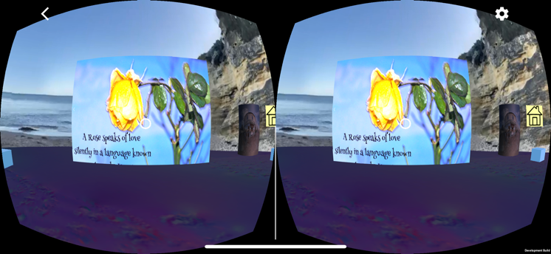

**COMPLETENESS** *(total 750 pts***)**

1. …
2. Diagetic UI – 250 pts

*Diagetic images used on canvases to control play/stoop and rewind video.*

*Diagetic objects allow user to choose ending by pointing and clicking at 3d game object cyclinders displaying images of café and restaurant.*

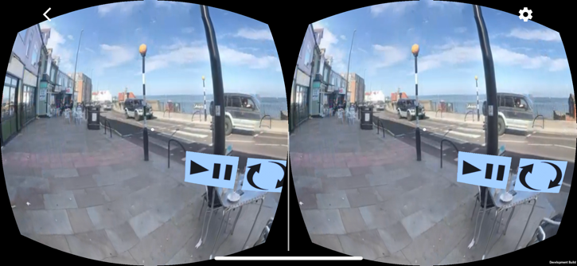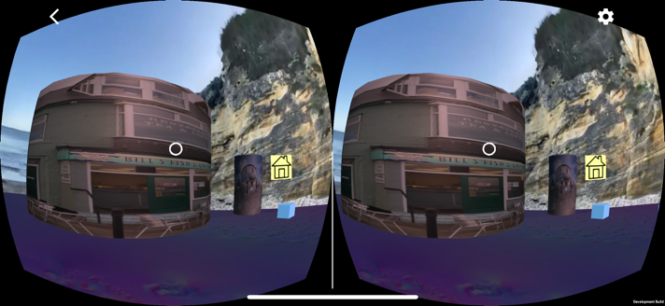

1. Alternative Storyline - 250 pts

*Narrative leads user to make a choice of going to Bills fish and chip takeaway/ restaurant or Beaches and Cream. Teleport to a VR experience for inside the cafes.*

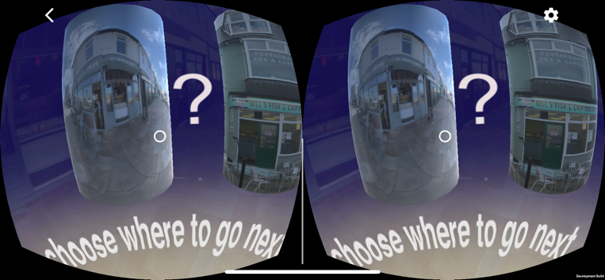

1. AI – 250 pts

Algorithm used to display seagulls flocking in Main scene at point where coolurful effects added to view of Cullercoats bay from the cliff top.

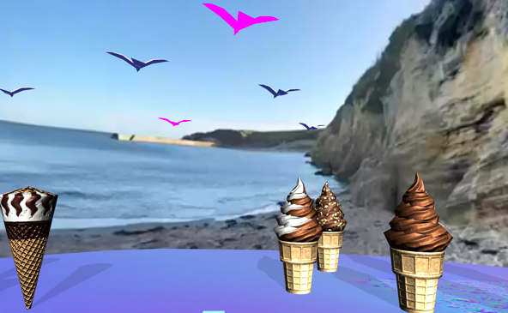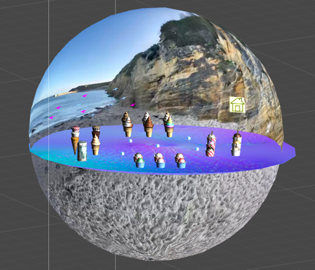

1. …
2. Photogrammetry

*3D fbx image of “little blue bendy Man” made. Used as an interactive “narrator” at various point in main scene to allow user the option to hear further audio description of Cullercoats and view slide show displayed as canvas.*

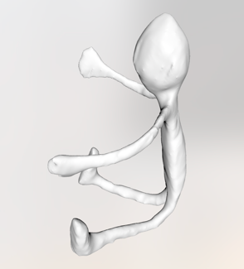

**CHALLENGES** (total 1,000 pts)

1. …
2. User Testing - 2 x 250 pts as >750 Completeness pts

extensive user testing performed with subsequent modifications made to app.

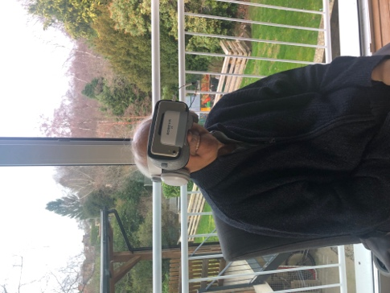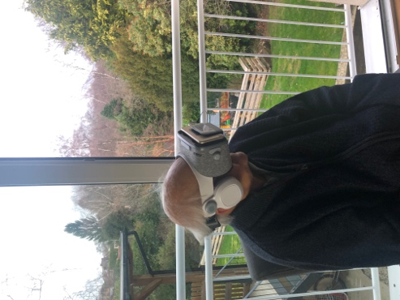

1. Compute Shader achievement - 500 pts

*Unlit Flippy Shader written to allow 360 video to be rendered and played back on inside of a Video Sphere. With camera centred at 0,0,0 and video sphere centred at 0,0,0 the user views the 360 video from the view point of being immersed right in the middle of the video simulating a 360 real life experience.*

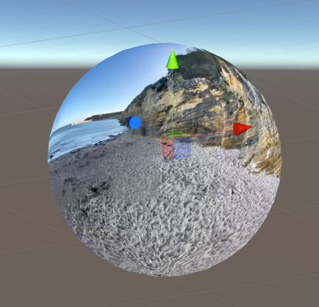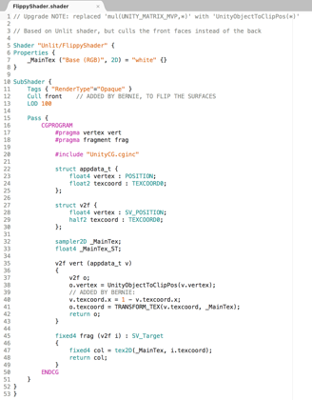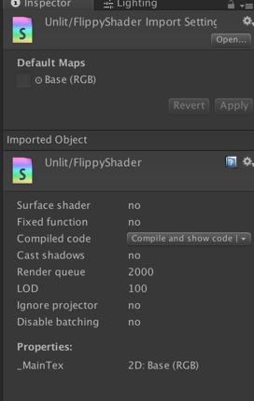

1. …

5. …

6. App store -

*I am definitely aiming to do this - after additional 360 video/images are taken in Feb 2019 to enhance and widen user experience & quality.*

**Audience**

Multiple target audiences

1. The inspiration for this app was a personal journey in memory of my mother and for my family to remember fun family experiences at Cullercoats. She was a wife, grandmother, sister, daughter, grand-daughter and aunt. More importantly she was a very determined, kind and fun loving for everyone. We all enjoyed the simple beauty of Cullercoats followed by Bill’s fish’n chips and Beaches and Cream (especially the meringues) many times.
2. For any Geordies (people from Newcastle area, England, UK ) who want to remember the fun of being at Cullercoats. Maybe they are too old to travel there, or infirm or disabled in some way or have some sort of special difficulty that results in limitations in travel and being outside. Maybe they just want to remember the old-fashioned fun of being at the Northumbrian coastal fishing village.
3. For anyone interested in a light hearted historical view point of Cullercoats
4. For anyone interested in a travel experience & to promote tourism and local businesses.
5. For tourists who are visiting Cullercoats and can maybe hire a head setfrom the Fisherman’s Lookout community centre , and sit on the welcome memorial benches. The benches are often colourfully decorated with flowers and have agreat vista overlooking the horse-shoe bay . This would certainly bring some life back to the fisherman’s community watch cottage!

-------------------------------------------------------------------------------------------------------------------------------------------

**Purpose / Emotions**

To induce happiness and memories that will inevitably be for many be a mixture of fun and the sadness of a loss of sharing these fun times with loved ones.

To promote local businesses in Cullercoats especially post development of the Spanish City at Whitley Bay and the competition it now provides for tourism.

Of therapeutic value.

I am passionate that interactive and engaging 360 experiences can be used as stand alone experiences or better still augmented and combined with real experiences. Emphasis on 360 and augmented reality with just a fun touch of virtual reality.

I believe that this can best be done using 360 domes for a shared and more social experience whenever possible.

However personal VR headsets are fun too.

**For example …**

I envisage a fun day in a care home or special needs facility or just for an elderly familymember or friend where users can sit in a 3D dome or wear headsets and have a fun experience.

This could serve as an introduction to capture the imagination of a real time experience where there is a room or an outside area (weather permitting) with beach chairs, parasols, sandpits with bucket and spades, a paddling pool and an ice cream cart or a visit from an ice cream van and a fish and chips stall.

Maybe combining it with Geordie music.

Or even just with a stick of rock (candy).

Why not combine it with a visit from nursery school children to share the joy of playing in the sand and paddling pools?

An alternative idea is 360 headsets for hire or a dome experience (maybe within the fisherman’s watch room) so those unable to make the ramp down to the beach can “live” the experience from the top of the cliff and then go across to the real Beaches and Cream / Bill’s fish and chips.

**Original Plan v Actual Project**

***Main Scene***

* ~~Start with opening Cullerfornia canvas placed over 360 video~~

Need to do this – just ran out of time

* VIDEO PLAYER ACHIEVEMENT - Display 360 video in sequence of clips (set up as an array) as showcase for Cullercoats
* COMPUTER SHADER ACHIEVEMENT – use Unlit Flippy Shader top [lay video on inside of sphere
* Play audio to match video clips (set up as array)
* Play next clip automatically when video and audio of previous clip has ended
* EMPATHY ACHIEVEMENT – create immersive experience showing joy of Cullercoats touched with some sadness as remembering “old times” also often produces feeling of some sort of loss
* PHOTOGRAMMETRY - Produce 3D fbx mode of a toy bendy man using photogrammetry to use an interactive 3rd person in scene –

NB – model produced not good enough quality to use but still want to get this working on a 2nd version

* ~~Place rag doll in scene with animation~~
* ~~Add additional narration and play videos/images when rag doll is clicked~~

Feel this is an important part of the interactivity with the 360 video and takes the app to the next level and so is a must do for Version 2

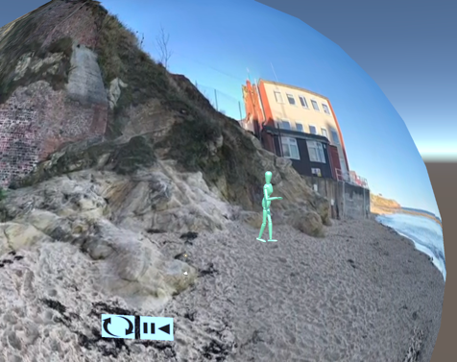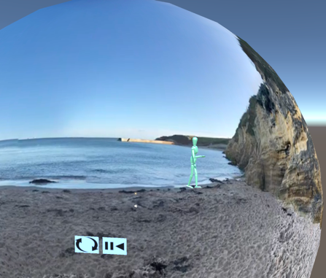

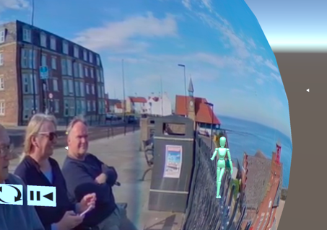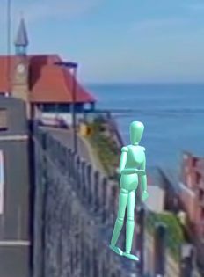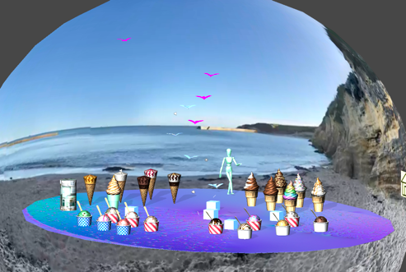

* ~~Display seagulls circling at start of video~~

Just simply ran out of time

* DIAGETIC UI - Add control to play/pause and restart video
* ALTERNATIVE ENDINGS - At end of video display interactive objects so user can choose between endings (go to Beaches & Cream café or Bills Fish ‘n Chips shop)
* Clicking on shop/café takes user to separate scene
* Add particles (seagulls) at relevant point in beach scene

**Beaches & Cream café / Ice Cream scene**

* Set up 360 image/video as skybox background
* Add Audio music – oh I do like to be beside the seaside
* SCALE ACHIEVEMENT - Display giant ice-creams on cyclinder stand
* LOCOMOTION ACHIEVEMENT - Add waypoints to walk around ice-creams
* Make ice-creams interactive
* ~~On gaze then display ice-cream description~~

Coding & some descriptions in place. Just need time to add all the canvas details

* Point & click to choose ice-cream
* AI ACHIEVEMENT - Display seagulls circling using AI algorithm and with audio source attached to 2 seagulls
* Display canvas on click to say Thanks for order
* Controls – can go back to Home Scene or to Bills fish ‘n chips
* Interactive canvas – go to Home scene
* Interactive shop cyclinder to teleport to Bill’s fish ‘n chips.

**Bill’s fish and chips shop**

* Set up 360 image/video as skybox background
* ~~Place model representing fish and chip shops on beach~~

Purchased a model but Unity in MacOS doesn’t allow automatic import of 3D Studio Max models

Something I want to work out how to do

* ~~Display menu items as canvas or interactive objects to choose food order~~

Ran out of time to do this but would like to explore further

* Due to time constraints had to just show slide show of food options & more about Cullercoats
* Display 2D video of Cullercoats “whilst the user waits for food”
* Use Bendy Man as 3rd person narrator to describe more of tales of Cullercoats

**Performance, Artistic & User Testing**

* USER TESTING ACHIEVEMENT – see below

-------------------------------------------------------------------------------------------------------------------------------------

**Testing**

Artistic Experimentation combined with User Testing and Performance Testing

**---------------------------------------------------------------------------------------------------------------------------------------------**

**Performance /Technical Testing**

Examined different ways of displaying 360 Video / Images in Unity app (using iMac for development and iPhone for deployment)

1. using 360 Video sphere with flippy shader
2. using 360 Video displayed as skybox using Panoramic Shader
3. using 360 images displayed as skybox

Conclusion there didn’t seem to be any difference in ….

**User / Artistic Effects Testing**

1. **Displayed 2D images superimposed over 360 Video/Images** in Adobe PremierPro with 2D images superimposed on to see effects in 360 VR Unity app.

Example images of Bills Fish ‘n chips shop. Tried different sized images to see if could make over-effect smaller.

***Result.***

User responses – too large and can’t see what is really going on

No matter what size images were they still displayed as over-sized in Unity and no control over positioning.

***Ammendment***

Decided to do this in Unity using a canvas to display images of choice of endings – Beaches and Cream or Bill’s.

1. **Displayed 2D images as canvas** in Unity app over 360 video.

***Result***

Worked fairly well.

User response was that wanted to be able to walk inside the café/restaurant and eat the ice cream / fish and chips.

***Amnendment***

Decided to create a new scene for each of Beaches and Cream and Bill’s fish and chips using 3D

modelling to create a virtual experience of walking into the café/shop/restaurant.

1. **Display 2d images on interactive 3D game objects (cyclinders**).

Experimented with blurring of 360 video background and then instantiating cyclinders. Displayed 2D image of Bills fish and chips shop on one. Only had 3D image of front of Beaches and Cream to display on second cylinder.

Set up cylinders as interactive game objects. User enters the café depending on choice of ending.

***Result***

User feedback was that 2D image worked of Bill’s fish and chips and created a very realistic effect.

Effect for 3D image of Beaches & Cream didn’t work as well but still created an overall pleasing and welcoming effect. Created a more immersive experience.

1. **What do you think of the video?**
2. **Is it obvious how to stop/start/replay the video?**
3. **How does Beaches and Cream experience make you feel?**
4. **How does Fish and Chips shop experience make you feel?**
5. **Is it obvious how to get back to the main scene?**
6. **What did you think of the app?**
7. **What did you like best?**
8. **Anything you didn’t like?**
9. **Would you like to see it again if I promise not to ask you any more questions?**
10. **Is there anything I should do different or add to the app or get rid of?**
11. **Any other comments***? (open ended question at end)*

**Timescales ( all minimums targets)**

It always takes longer to create the first prototype especially with new technology and leading edge 360 technology.

These timescales are minimums only. Higher quality and more details are open ended in nature, both in terms of possibilities and development times.

Remember the whole production and development process is an iterative one.

**Approximates**

Project planning using hand drawn mind maps … 2 hrs

NB. An iOs app will probably only consists of 3-6 scenes due to performance and memory constraints.

**Videos, Images & Audio Production & development**

* Production of 5 or 6 x 360 images /videos of the Cullercoats bay … 2 hrs
* Lead times to pre-arrange taking videos/images with local proprietaries (Beaches and Cream and Bill’s fish and chips) .. 1 day
* Production of 360 photos/videos inside shops, cafes & restaurants … 2 hrs
* Production of each 360 video compilation using Adobe Premier Pro specifically equating to a scene in Unity … 2 hrs.
* Matching audio to each video … 4 hours minimum
* 360 Photogrammetry of specific 3D objects … 2 hrs
* ***Subtotal … 26 hrs. (3-4 days)***

**Unity app production & development**

* Creating each scene in app - using the existing framework of an interactive 360 video app (StoryTellersRevenge in this case) … 4 hrs
* Development of interactive canvases and objects plus visual effects for each scene. Using Unity assets for particles, 3D models of objects (example – ice-creams, fish and chip shop) … 2 hrs
* Adding audio / music for each scene …. 4 hrs
* ***Subtotal for 3 scenes … 30 hrs (2-3 days)***
* Game logic tying scenes together … 4 hrs
* Performance Testing … 1 day
* User Testing … 1 day
* Revisions to app … 1 day
* ***Subtotal … 28 hrs. (1-2 days)***

***Contingency … 10-20%***

**Total minimum development time for 3 scenes .. 6-9 days (2 weeks)**

**Reality –** it takes more like a minimum of 3-4 weeks especially after uploading to github, version control, documentation and if sending to apple store for review and publishing !

***************************************************************************************

**DEVELOPMENT**

**\*\*\*\*\*\*\*\*\*\*\*\*\*\*\*\*\*\*\*\*\*\*\*\*\*\*\*\*\*\*\*\*\*\*\*\*\*\*\*\*\*\*\*\*\*\*\*\*\*\*\*\*\*\*\*\*\*\*\*\*\*\*\*\*\*\*\*\*\*\*\*\*\*\*\*\*\*\*\*\*\*\*\*\*\*\*\* Videos/Images Production & Performance Optimisation**

Videos were made out of 360 still images so effects could be added using Premier Pro

Images/ videos recorded using Ricoh Theta V 360 camera

Stitching and auto-correction using Ricoh Theta File Transfer for Mac

Adobe Premier used to compile stills into 360 video

Added effects such as transitions and colour with title pages used to produce background for choice of endings

Insta360 Studio used to view 360 videos

Handbrake used to transcode videos into fast1080p30 codec for optimised performance

Audio produced using iPhone Dictaphone

Switch used to transcode audio files into required format

As audio longer than video segments and did not want to increase size of videos that would have decreased performance and lengthened time of initially loading the app - to optimise performance - Adobe Premier used to break rendered videos into segments (video scenes)

Video segments then loaded into a Video array as part of the Unity VideoPlayer

New video segment loaded into video array at end of corresponding audio clip

Interactive objects, canvases and particle effects added in Unity

**Narrative**

Video and matching audio playback with special effects controlled within Unity (VideoController.cs and VideEffects.cs).

***Video Scene 1***

The main scene opens at the water edge of Cullercoats bay with the interesting rock strata details behind the main view point. Cullercoats is a tiny, fishing village on the Northumbria coast not far from the mouth of the river Tyne. Music … accompanies the scene with first person narration. Further along the bay is the historical Newcastle University marine lab built in xxx and the LifeBoat station built in .

***Video Scene 2***

*The shot pans left towards the lifeboat station focusing on the ramp leading down. The basic history of the station is told by the narrator with an option to click on “the little blue man” for further details of the great rescue of xxxx.*

***Video Scene 3***

Climbing up the boat ramp to the rear of the Lifeboat station leads to the cliff top where the prominent feature is the fisherman’s watch out with clock tower. Built in xxx, it is now a community centre.

***Video Scene 4***

The cliff top edge is conveniently dotted with memorial benches . Cullercoats in all it’s glory is actually now promoted as the North of England’s alternative of California. Promoted by the local council as Cullefronia it is indeed very colourful in all meanings of the word.

***Video Scene 5 & 6***

Crossing the road there are a number of restaurants. My favourite are Beaches and Cream café and further up the road, Bill’s fish and chips. It’s a time led tradition especially in the North if England to end a beach day with locally sourced fish and chips. Then again who can resist afternoon tea with meringues or an ice-cream?

***Video Scene 6***

The café and restaurant images are displayed on interactive cyclinder game objects to allow the user to choose the ending. Or they can just click on the “little blue man” to find out more about the street of fisherman’s huts where fresh catches of the day were sold and the boat yard full of fisherman’s coval boats just a further 100 metres up the road. Oh and there is the White House famous for it’s smugglers covesand caves. Legend says the caves lead to tunnels that end up in secret rooms in the basement of the house.

**Interesting?**

Just download & play the app

**TECHNICAL DOCUMENTATION**

***************************************************************************************

**SCENES**

**_____________________**

**Main, BeachesNCream, Billsfnc**

1. **Main**

360 video introduction to Cullercoats bay with a choice of endings. Choice is to go to Beaches and Cream for ice-cream or to go to Bills Fish and chips shop.

Plays 360 Video on a Sphere using an Unlit/FlippyShader streaming video from Assets/Videos

***3D objects –*** interactive 3D models / rag doll

***Photogrammetry -*** *3D bendy man built through photogrammetry app – click on to provide further narrative and canvases*

***Interactive objects –*** *3D bendy an, cyclinders representing café and restaurant*

***Canvases – my Mum, fisherman’s watch out*** - look out view

***Particles –*** colourful Cullercoats – seagulls

***Visual effects-***

***Memorial canvas -***

***Diagetic Controls***are provided to play/pause video, restart video scene and go back to Home scene

***Choice of ending*** – Additional diagetic controls at end of video to allow user to choose between endings – go to BeachesNCream café scene or Bill’s fish and chips.

***Diagetics***

At end of video sequence images of Beach and Cream Café and Bill’s fish and chips are displayed on two cyclinders. A UI canvas displays “?” inbetween the two cylinders to signify user choice.

Or

Leads user into Bill’s fish and chips using a canvas as a portal

_____________________________________________________________________________________

1. **BeachesNCream**

Leads user into Beaches and Cream café scene through a canvas image of the shop front acting as a portal to a new scene (IceCreams) where there is a choice of ice creams on offer

Plays 360 Image on a Sphere using an Unlit/FlippyShader streaming video from Asstes/Images

**Waypoints** are provided so user can walk around giant ice creams to make choice.

***Controls***are provided to play/pause video, restart video scene and go back to Home scene

Addition control to allow user to choose other ending.

***3D objects –***

***Interactive objects -***

***Canvases -***

***Particles -***

***Visual effects-***

***Memorial canvas -***

____________________________________________________________________________________

**3. Billsfnc**

Leads user into Bill’s fish and chips restarant/take away scene through a canvas image of the shop front acting as a portal to a new 3D virtual model of a fish and chip shop. Entry through the door leads to a new scene (FishnChips) where there is a choice of food and drinks on offer

Plays 360 Image on a Sphere using an Unlit/FlippyShader streaming video from Asstes/Images

***3D objects –***

***Interactive objects -***

***Canvases -***

***Particles -***

***Visual effects-***

***Memorial canvas -***

**Waypoints** are provided so user can walk around giant food and drink items to make choice.

***Controls***are provided to play/pause video, restart video scene and go back to Home scene

Addition control to allow user to choose other ending.

**SCRIPTS**

**VideoController.cs**

*Controls videos played onVideo Player component*

*Videos can be set up as an array of clips*

*Use Video Clips/Size to set up size of array*

*Use Video Clips/E;ements to assign video clips*

*Video Clip Index used to reference individual video clips*

*Video clip index incremented to allow next clip in array to be played*

Controls Play/Pause/Restart and Home

Can also display current time, total time of video clip as well as display fraction on a progress bar

Controls canvas to allow option to play next video clip – referenced by GvrNextButtonControl

Option on last script to display canvases or interactive objects to allow user to choose between endings

***GotoDiffScenes.cs*** used to play new scenes – each video streamed is set up as a new scene

***GvrPlayPauseURL.cs, GvrRestartUR.csL, GvrHomeButton.cs***

Used to control Play, Pause, Restart and Home

***GvrPlayPause.cs, GvrRestart.cs***

Used to control Play, Pause, Restart and Home

***GvrHomeButton.cs & GotoDiffScenes.cs***

Used to got to Main scene and different scenes

***VideoEffects***

Was set up so that video effects such as interactive gameobjects and particles etc could be played and set up in a different file

However when streaming videos this would again risk slowing dowm=n play back so the code was incorporated into VideoURLController

**______________________________**

**GAME OBJECTS**

**Video Player components**

***Progress Bar*** game object

Used to control video playhead progress bar with a canvas used to display overall length of video and current time

NB. This is diasbled to try and improve mobile performance as performance of video played is more important than this feature

___________________________________________________________________________________

**Performance Optimisation**

Static game objects are baked

Fixed update?

Videos split into segment and control of audio matching video sequence handled within Unity to reduce length and therefore size of video to reduce time for loading app initially, save memory and imprive iverall performance.

**Timescales ( all minimums targets)**

It always takes longer to create the first prototype especially with new technology and leading edge 360 technology.

These timescales are minimums only. Higher quality and more details are open ended in nature, both in terms of possibilities and development times.

Remember the whole production and development process is an iterative one.

**Approximates**

Project planning using hand drawn mind maps … 2 hrs

NB. An iOs app will probably only consists of 3-6 scenes due to performance and memory constraints.

**Videos, Images & Audio Production & development**

* Production of 5 or 6 x 360 images /videos of the Cullercoats bay … 2 hrs
* Lead times to pre-arrange taking videos/images with local proprietaries (Beaches and Cream and Bill’s fish and chips) .. 1 day
* Production of 360 photos/videos inside shops, cafes & restaurants … 2 hrs
* Production of each 360 video compilation using Adobe Premier Pro specifically equating to a scene in Unity … 2 hrs.
* Matching audio to each video … 4 hours minimum
* 360 Photogrammetry of specific 3D objects … 2 hrs
* ***Subtotal … 26 hrs. (3-4 days)***

**Unity app production & development**

* Creating each scene in app - using the existing framework of an interactive 360 video app (StoryTellersRevenge in this case) … 4 hrs
* Development of interactive canvases and objects plus visual effects for each scene. Using Unity assets for particles, 3D models of objects (example – ice-creams, fish and chip shop) … 2 hrs
* Adding audio / music for each scene …. 4 hrs
* ***Subtotal for 3 scenes … 30 hrs (2-3 days)***
* Game logic tying scenes together … 4 hrs
* Performance Testing … 1 day
* User Testing … 1 day
* Revisions to app … 1 day
* ***Subtotal … 28 hrs. (1-2 days)***

***Contingency … 10-20%***

**Total minimum development time for 3 scenes .. 6-9 days (2 weeks)**

**Reality –** it takes more like a minimum of 3-4 weeks especially after uploading to github, version control, documentation and if sending to apple store for review and publishing !

**Development**

**\*\*\*\*\*\*\*\*\*\*\*\*\*\*\*\*\*\*\*\*\*\*\*\*\*\*\*\*\*\*\*\*\*\*\*\*\*\*\*\*\*\*\*\*\*\*\*\*\*\*\*\*\*\*\*\*\*\*\*\*\*\*\*\*\*\*\*\*\*\*\*\*\*\*\*\*\*\*\*\*\*\*\*\*\*\*\***

**STORY TELLERS REVENGE**

**Description**

The StoryTellersRevenge is a prototype for a 360 video app voyaging the world with special focus on Califronia and Cullerfornia (Cullercoats Bay, England).

The main scene sets the scene with a desk with a story book that can be opened and pages turned with accompanying narrative providing intro to the story line for the app. Frozen island is satirical take on a desert island without sun.

The VidIntro scene leads the user into amazing 360 journeys travelling the seas and exploring deep blue waters around the world. More of a Protaginist Journey.

The user then gets to choose 1 of 2 endings – California or Cullerfornia. Cullerfornia is how the local tourisyt board sell Cullercoats Bay, in the NE England, United Kingdom.

The theme throughout is waters.

3D particles and animated objects are superimposed onto 360 video to add interest and evoke fun.

**----------------------------------------------------------------------------------------------------------------------------------------**

**Development Process**

360 videos of world travel provided by Udacity were used for the Intro video.

360 videos were stitched using AutoPano Pro and balanced using AutoPano Giga.

360 videos for Ending 1 were taken using a Ricoh Theta V 360 camera. Files were stitched using RicoTheta app.

Videos and audio were edited in Adobe Premier Pro.

Handbrake was used to convert files into a fast1080p30 format.

Switch was used to convert audio files into .wav files.

Google Resonance Audio was used to play audio so audio was handled within Unity.

Videos are all streamed from a dropbox folder.

This was quite a technical challenge using so many packages and applications – working out correct file formats and trying to overcome problem of streaming videos on an iPhone with only mediocre internet access.

I set up a Test360Video application in Unity just to test streaming – with bare minimum files – and found that the performance of streaming videos in this test was quite slow and probably not very encouraging for a user.

Until streaming performance within a Unity app can be improved then I think I will stick to importing videos into the Unity assets files rather than depend on variable result s of streaming.

I want users to want to use my app again and to be sure that audio and video synchronise.

However there was a lot to be learnt in a very lengthy and re-iterative process.

----------------------------------------------------------------------------------------------------------------------------------

**SCENES**

**Scene : Main**

Zooms into desk with closed book, Vacation box and 4 coloured cubes.

Particles and rotating title – based on PowerBooks asset

Click on book to open pages and listen to narration (introduction)

Click on Vacation Box to goto FrozenIsaldn scene

Click on cubes to go to interactive 360 video scens

Blue box -> bluewater video

**Scene : FrozenIsland**

**Scene : VidIntro**

Plays 360 Video on a Sphere using an Unlit/FlippyShader streaming video from a URL to a dropbox link

Controls to play/pause video, restart video scene and go back to Home scene

When intro ended then 2 canvases appear to allow user to choose ending 1 or ending 2

**Scene : VidEnd1**

Plays 360 Video on a Sphere using an Unlit/FlippyShader streaming video from a URL to a dropbox link

Controls to play/pause video, restart video scene and go back to Home scene

Addition control to allow user to choose other ending

**Scene: VidEnd2**

Plays 360 Video on a Sphere using an Unlit/FlippyShader streaming video from a URL to a dropbox link

**Controls** are provided to play/pause video, restart video scene and go back to Home scene

Addition control to allow user to choose other endings. >>

**Video links :**

# Intro –

# *Intro : IntrovFinalVideoFast1080p30*

https://www.dropbox.com/s/ina2t6m8oik2uny/IntrovFinalVideoFast1080p30.mp4?dl=0

# Ending1 : California - California9fast1080p30.mp4

<https://www.dropbox.com/s/s1hgel5uqga5evb/California9fast1080p30.mp4?dl=0>

1. Ending 2 : Cullerfornia. CullerfroniaFast1080p30.mp4

<https://www.dropbox.com/s/eay2bomeg3jd37e/CaliforniaFast1080p30.mp4?dl=0>

https://www.dropbox.com/s/ffxtykrzg5yivxw/CullerfroniaFast1080p30.mp4?dl=0

**Technical Development**

An interactive 360VideoPlayer app – My360VideoPlayer2017-4 for a video player working for URL & skybox & fliipyshader methods

**Other Assets Useds**

PowerBooks, FreeMountain

------------------------------------------------------------------------------------------------------------------------------

**TestVideo used**

1. Short video example codec fast1080p using Handbrake - 3840x1920. MB

<https://www.dropbox.com/s/0ac5m1l6qr8y507/BW_Short.mp4?d=0>

1. Staycation video 1920 x 960. Fast1080p codec. Video HN dropbox. MB

<https://www.dropbox.com/s/norln14m8wbo8n5/BlueWaterStaycationFast1080.mp4?dl=1>

**TECHNICAL (scenes, Game Objects & scripts)**

**Streaming Videos**

Game currently set to stream videos from a URL to a DropBox file

Intro Video set up as Index 0 & **videoURL0**; Ending 1 Index=1 & **videoURL1**; Ending 1 Index=2 **VideoURL2**

For streaming from URL then URL scripts are used

***VideoURLController.cs*** used to control Play/Pas/Restart and Home

Project set up so Ending 1 and Ending 2 can be loaded up without leaving scene

However this seemed to delay streaming though)so other method used – each video set up as a different scene and scene loaded

***GotoDiffScenes.cs*** used to play new scenes – each video streamed is set up as a new scene

***GvrPlayPauseURL.cs, GvrRestartUR.csL, GvrHomeButton.cs***

Used to control Play, Pause, Restart and Home

**Playing Videos from Assets**

Project also set up so videos can be played from videos stored in Asssets/StoryTellersRevenge/Videos

In this case video clips names can be stored as an array with a video Clip index pointing to the array

Videos can be played by reloading a different video without exiting from the scene

***GvrPlayPause.cs, GvrRestart.cs, GvrHomeButton.cs with GotoDiffScenes.cs***

Used to control Play, Pause, Restart and Home

***Progress Bar*** game object

Used to control video playhead progress bar with a canvas used to display overall length of video and current time

NB. This is diasbled to try and improve mobile performance as performance of video played is more important than this feature

***VideoEffects***

Was set up so that video effects such as interactive gameobjects and particles etc could be played and set up in a different file

However when streaming videos this would again risk slowing dowm=n play back so the code was incorporated into VideoURLController

**Game Objects**

**Video Player component**

Set Source to URL and leave URL blank

URL is set in VideoURLController script

**Videos**

**3 different videos are used for Intro /Ending 1 and Ending 2**

**------------------------------------------------------------------------------------------------------------------------------**

--------------------------------------------------------------------------------------------------------------------------------------

**CHANGES LOG**

---------------------------------------------------------------------------------------------------------------------------------------

**Current Problems**

**21 Nov 2018**

Vid1 and Vid2 scenes set up to play video from Assets and not streamed – need to change

Can’t switch to diff endings from End1 and End2 scenes

**Method Used to create Scenes : 360Video, 360VidURL, 360Video-v2**

1. **Create New Render Texture**

Same size as video and 2D

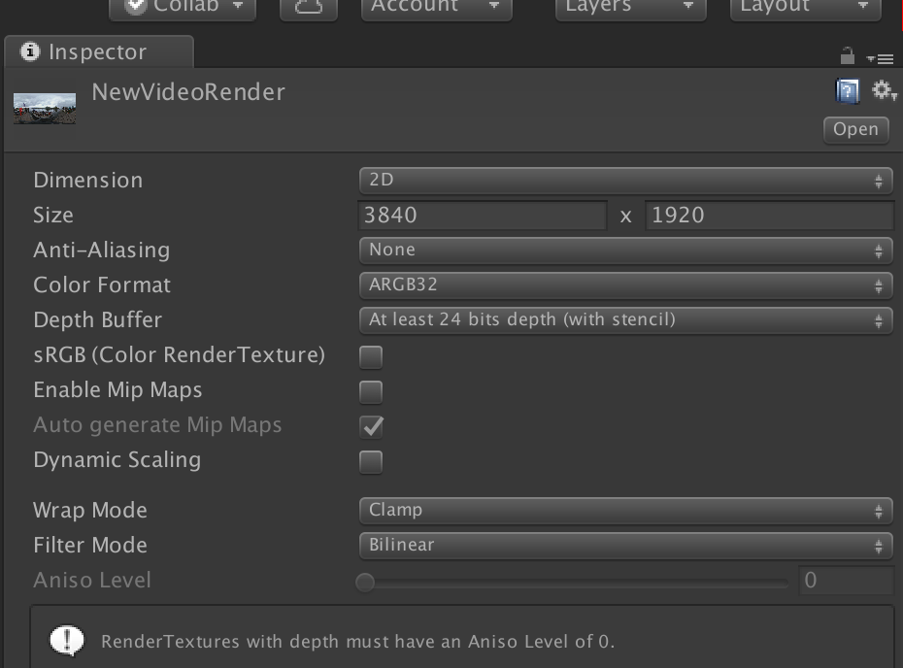

1. **Create new unlit shader – FlippyShader**

Open Shader (code)

Delete existing code and replace with this

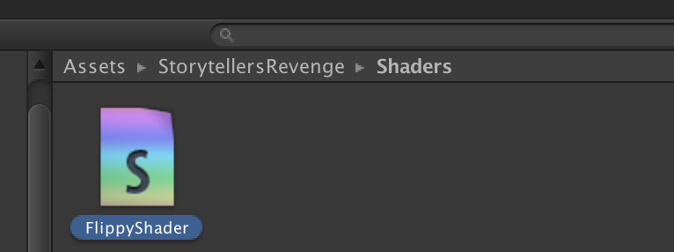

// Upgrade NOTE: replaced 'mul(UNITY_MATRIX_MVP,*)' with 'UnityObjectToClipPos(*)'  
  
// Based on Unlit shader, but culls the front faces instead of the back  
  
Shader "Unlit/FlippyShader" {  
Properties {  
    _MainTex ("Base (RGB)", 2D) = "white" {}  
}  
  
SubShader {  
    Tags { "RenderType"="Opaque" }  
    Cull front    // ADDED BY BERNIE, TO FLIP THE SURFACES  
    LOD 100  
  
    Pass {    
        CGPROGRAM  
            #pragma vertex vert  
            #pragma fragment frag  
  
            #include "UnityCG.cginc"  
  
            struct appdata_t {  
                float4 vertex : POSITION;  
                float2 texcoord : TEXCOORD0;  
            };  
  
            struct v2f {  
                float4 vertex : SV_POSITION;  
                half2 texcoord : TEXCOORD0;  
            };  
  
            sampler2D _MainTex;  
            float4 _MainTex_ST;  
  
            v2f vert (appdata_t v)  
            {  
                v2f o;  
                o.vertex = UnityObjectToClipPos(v.vertex);  
                // ADDED BY BERNIE:  
                v.texcoord.x = 1 - v.texcoord.x;                  
                o.texcoord = TRANSFORM_TEX(v.texcoord, _MainTex);  
                return o;  
            }  
  
            fixed4 frag (v2f i) : SV_Target  
            {  
                fixed4 col = tex2D(_MainTex, i.texcoord);  
                return col;  
            }  
        ENDCG  
    }  
}  
}

**3.Create New Material**

**I** 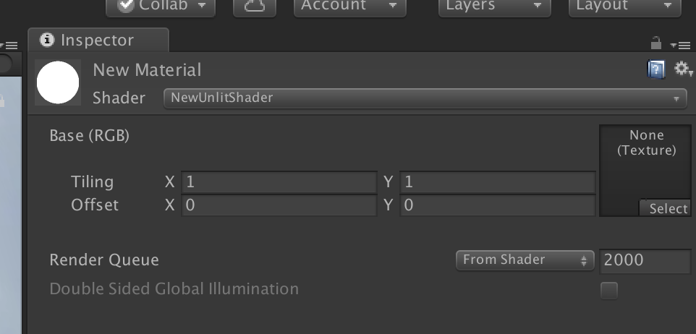

1. **In Assets/Materials drag NewUnlitShader onto New Material**

With NewMaterial and FlippyShader in same directory (Assets/Materials)

Drang FlippyShader onto New Material

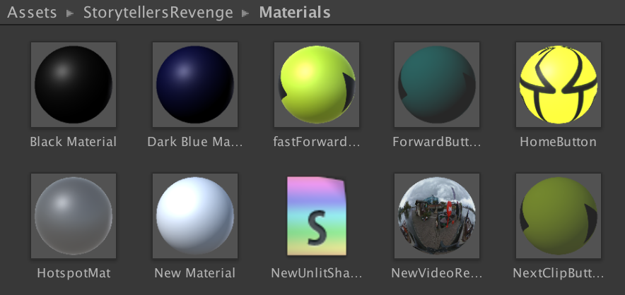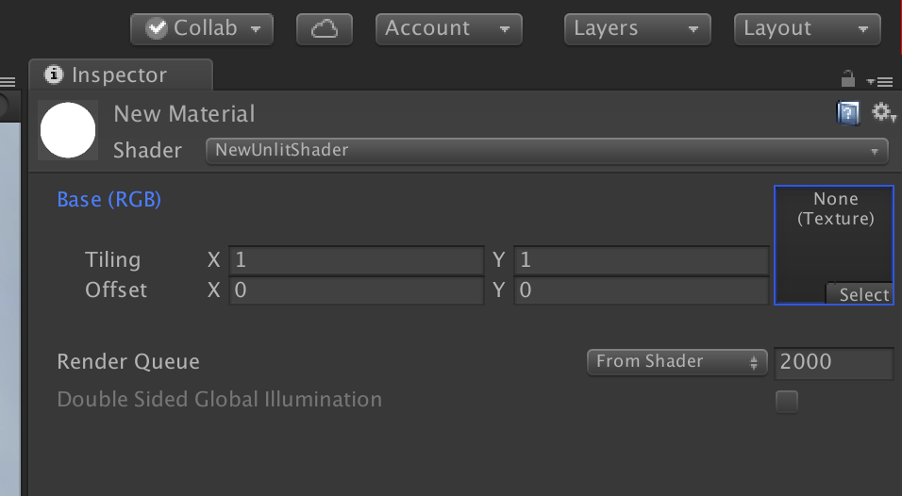

1. **From Assets / Textures drag NewVideoRender texture into Select box of NewMaterial**

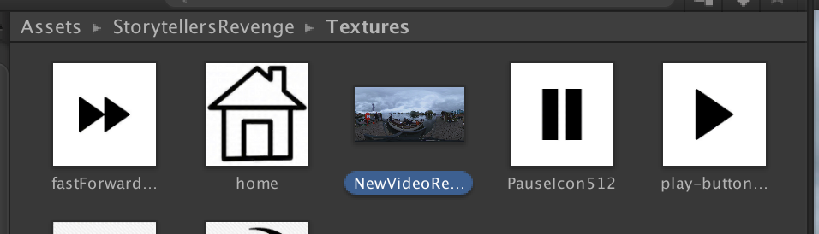

l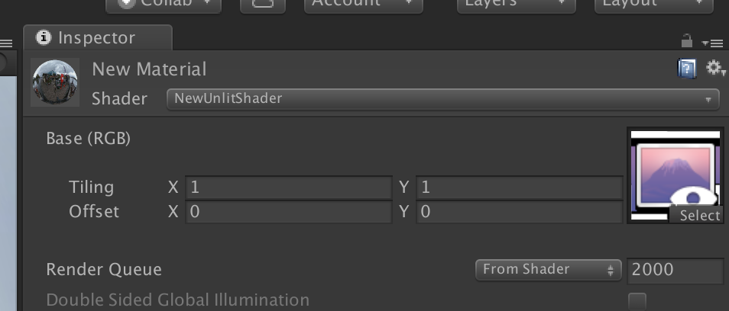

1. **Drag NewVideoMaterial onto VideoScreenSphere (mesh Renderer)**

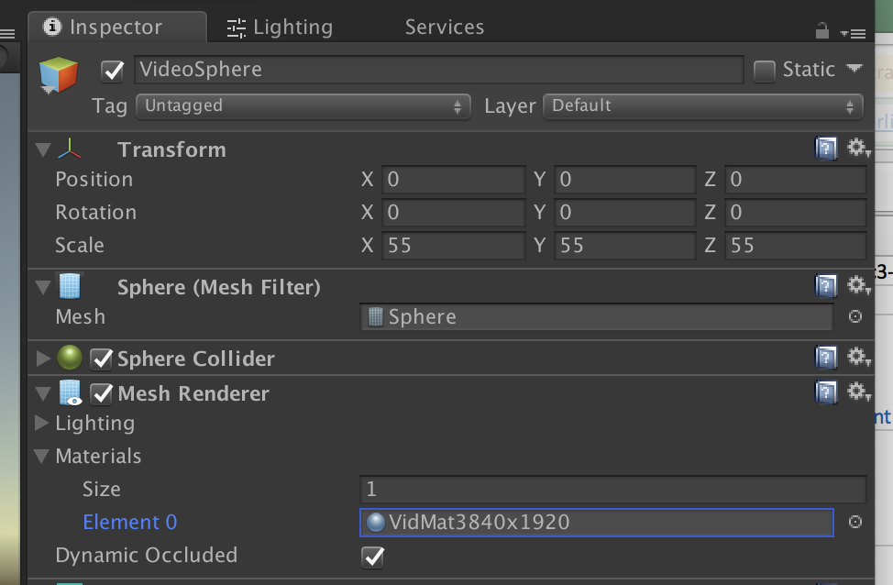

1. **Set NewVideoRender on VideoComponent**

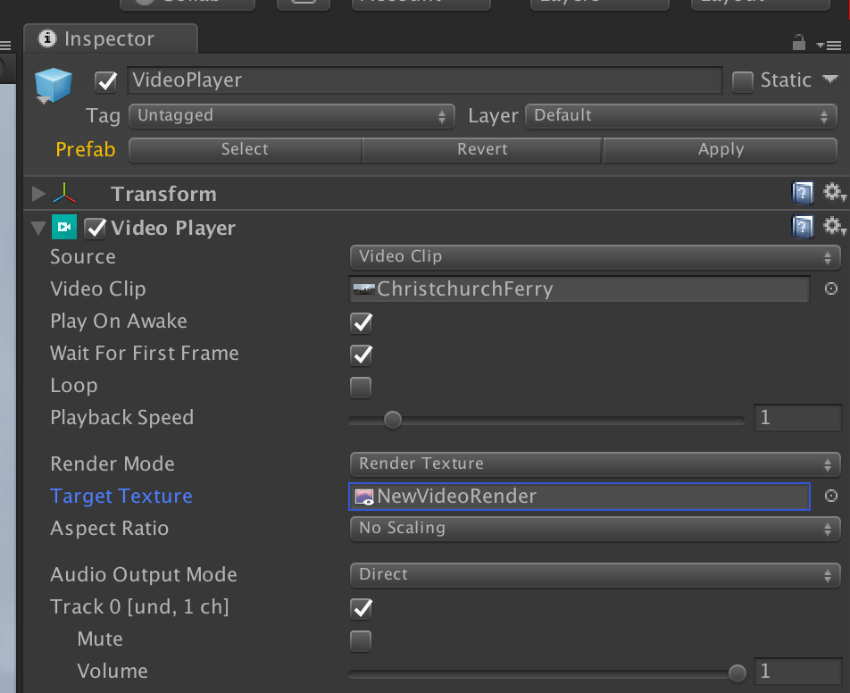

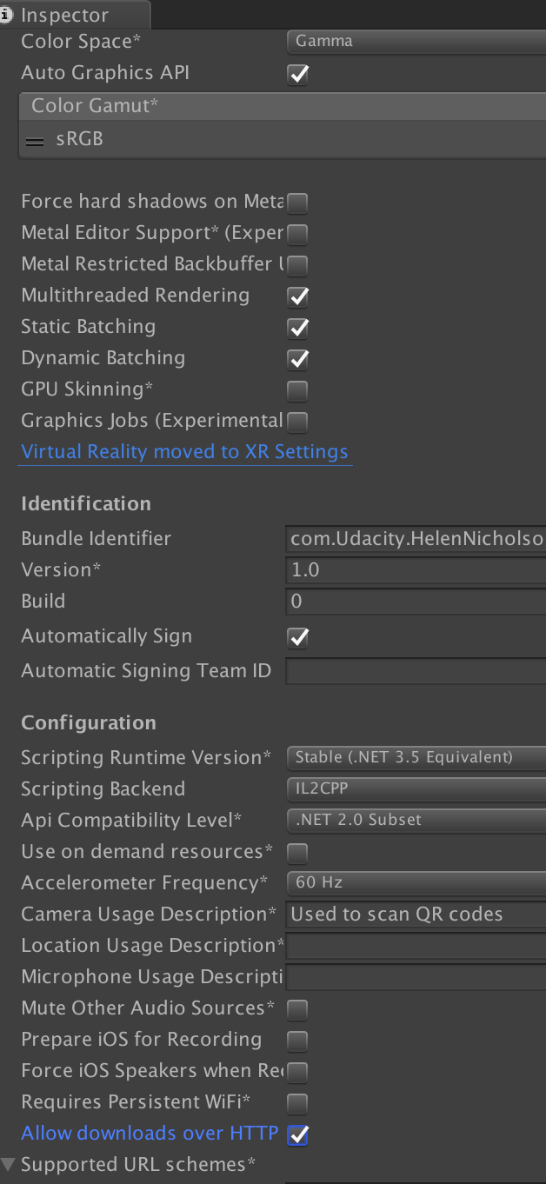

**\*\*\*\*\*\*\*\*\*\*\*\*\*\*\*\*\*\*\*\*\*\*\*\*\*\*\*\*\*\*\*\*\*\*\*\*\*\*\*\*\*\*\*\*\*\*\*\*\*\*\*\*\*\*\*\*\*\*\*\*\*\*\*\*\*\*\*\*\*\*\*\*\*\*\*\*\*\*\*\*\***

**B. Setting up video to play as skybox using Skybox/Panoramic shader**

1. **Add Video Player prefab component**

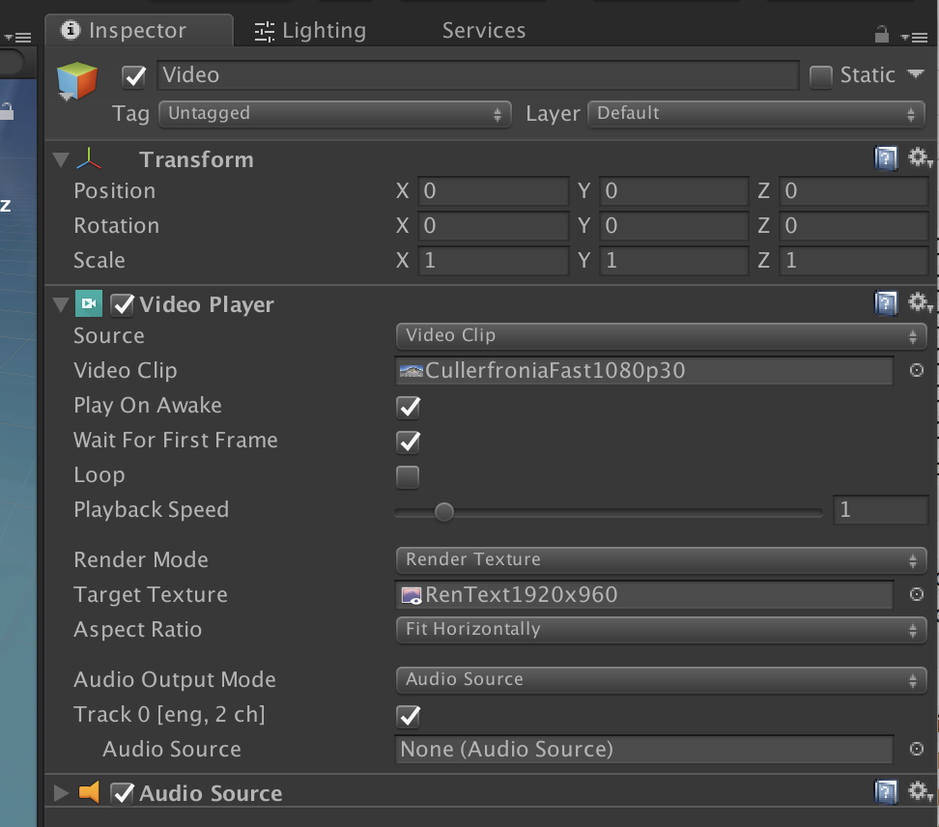

1. **Need to create a Render Texture to match size of video – add to Assets/Materials or Renders**

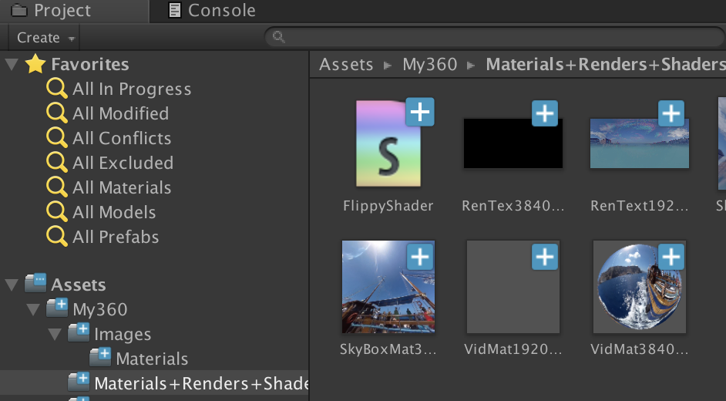

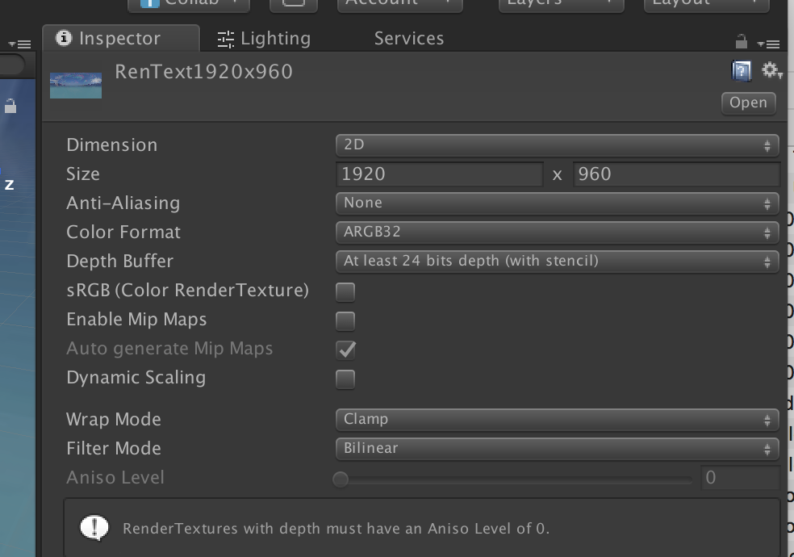

1. **Create a new SkyBoxMaterial & store in Assets/Materials- set shader to Skybox/Panoramic**

Create a Skybox Material

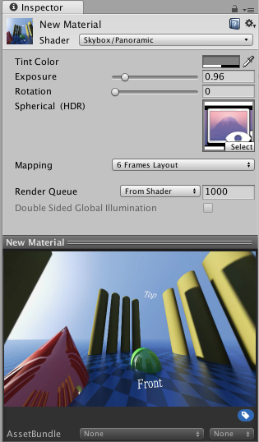

In order to render the panoramic video as a backdrop to our scene, we will replace the default Skybox with the video content. Do so by creating a new Material from the Assets->Create menu. Set the Material's Shader to Skybox/PanoramicBeta. Drag the Render Texture from the Asset view to the texture slot in the new material. In order for the panoramic video to be properly displayed, you will need to correctly identify the type of content in the video. For cubemap content (such as a cross and strip layout as is common for static skybox textures) select the 6 Frames Layout Mapping. For equirectangular, choose Latitude Longitude Layout Mapping and then either the 360 or 180 degree sub-option depending on if the video covers a full 360 degree view, or just a front-facing 180 degree view.

Once correctly set up, you should be able to pan around in the Preview at the bottom of the Material inspector and check that the 360 or 180 content looks correct.

**https://docs.google.com/document/d/1JjOQ0dXTYPFwg6eSOlIAdqyPo6QMLqh-PETwxf8ZVD8/edit#**

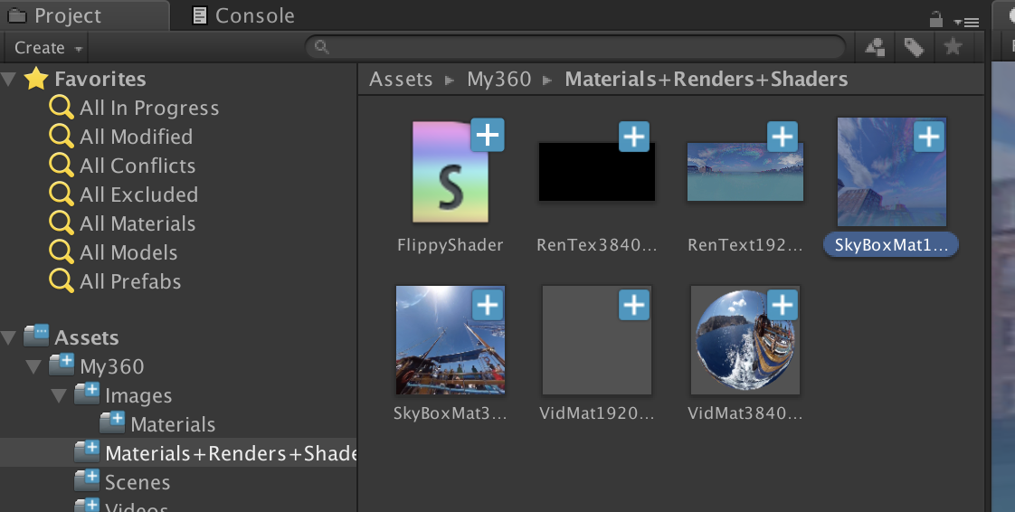

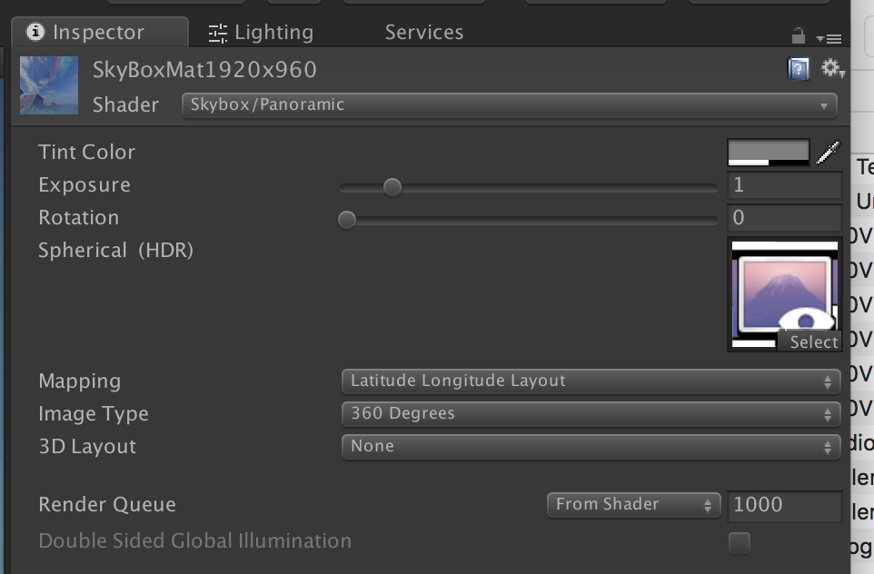

1. In Lighting panel set SKyBox Material as below



